1. what is cloud computing ? explain in detail ?

Ans : The practice of using a network of remote servers hosted on the internet to store, manage, and process data, rather than a local server or a personal computer.

In the simplest terms, cloud computing means **storing and accessing data and programs over the internet** instead of your computer's hard drive. The PCMag Encyclopedia defines it succinctly as "hardware and software services from a provider on the internet.

* Modernize existing applications.
* Build and scale cloud native applications.
* Migrate existing on-premises workloads to the cloud.
* Speed software and services delivery with DevOps.
* Integrate applications and data across multiple clouds.
* Accelerate your journey to artificial intelligence.
* Leverage 5G and edge computing.

Cloud computing is the **on-demand availability of computer system resources**, especially data storage (cloud storage) and computing power, without direct active management by the user. cloud computing is commonly known as delivery of computing services including servers, storage, databases, and intelligence over the Internet.The term is generally used to describe data centers available to many users over the Internet.

2.why cloud computing is required ?

Ans: Cloud technologies are becoming one of the major investments for organizations to**reduce costs; consolidate billing, availability, and disaster recovery; and enable BYOD and CYOD**. Why are so many businesses moving to the cloud? Cloud computing increases efficiency, helps improve cash flow, and offers many more benefits.

Cloud computing **is helping the society to cope with future problems such as managing big data, cyber-security and quality control**. In addition to this, emerging technologies such as Artificial Intelligence, distributed ledger technology, and many other capabilities are becoming available as services through [cloud computing](https://www.bing.com/search?q=Cloud+computing&filters=sid%3a0e95d5e1-1e66-476f-eda0-0bb417a12c37&form=ENTLNK).

Cloud computing is perhaps the most flamboyant technological innovation of the 21st century. This is because it has seen the fastest adoption into the mainstream than any other technology in the domain. This adoption has been fueled mainly by the ever-increasing number of smartphones and mobile devices that can access the internet. Cloud computing is not just for organizations and businesses; it’s also useful for the average person as well. It enables us to run software programs without installing them on our computers; it enables us to store and access our multimedia content via the internet, it enables us to develop and test programs without necessarily having servers and so on. Cloud computing is a 21st-century marvel that holds its importance in almost every field you can think of.

Most of us might be certainly asking ourselves the critical questions, why do we need cloud computing? Basically, we need cloud computing because of the numerous individual and business problems that we encounter today. These problems range from acquiring and maintaining expensive hardware and software resources that we use in our daily operations to streamlining these resources in the most efficient manner for our benefit and the benefit of the society at large. In handling these challenges, cloud computing offers numerous benefits that have surpassed our expectations and delivered more than we had previously thought. These benefits are discussed below.

3. Explain the architecture of cloud computing ?

Ans: Cloud Computing architecture comprises of many cloud components, which are loosely coupled. We can broadly divide the cloud architecture into two parts:

* Front End
* Back End

Each of the ends is connected through a network, usually Internet. The following diagram shows the graphical view of cloud computing architecture:

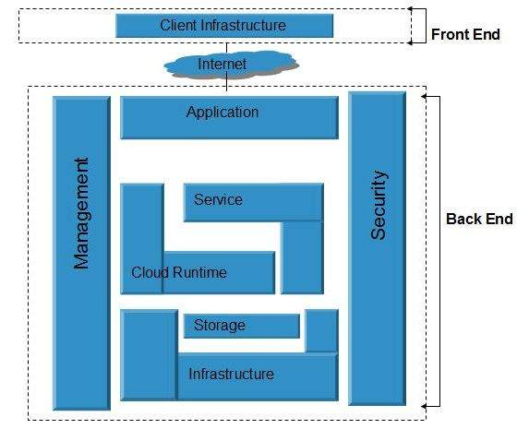

**Front End**

The **front end** refers to the client part of cloud computing system. It consists of interfaces and applications that are required to access the cloud computing platforms, Example - Web Browser.

**Back End**

The **back End** refers to the cloud itself. It consists of all the resources required to provide cloud computing services. It comprises of huge data storage, virtual machines, security mechanism, services, deployment models, server.

**Cloud infrastructure** consists of servers, storage devices, network, cloud management software, deployment software, and platform virtualization.

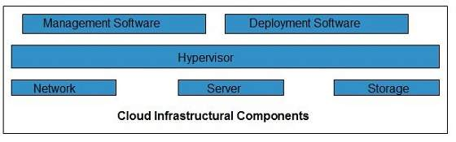

**Hypervisor**

**Hypervisor** is a **firmware** or **low-level program** that acts as a Virtual Machine Manager. It allows to share the single physical instance of cloud resources between several tenants.

Management Software

It helps to maintain and configure the infrastructure.

Deployment Software

It helps to deploy and integrate the application on the cloud.

Network

It is the key component of cloud infrastructure. It allows to connect cloud services over the Internet. It is also possible to deliver network as a utility over the Internet, which means, the customer can customize the network route and protocol.

**Server**

The **server** helps to compute the resource sharing and offers other services such as resource allocation and de-allocation, monitoring the resources, providing security etc.

**Storage**

Cloud keeps multiple replicas of storage. If one of the storage resources fails, then it can be extracted from another one, which makes cloud computing more reliable.

Infrastructural Constrains

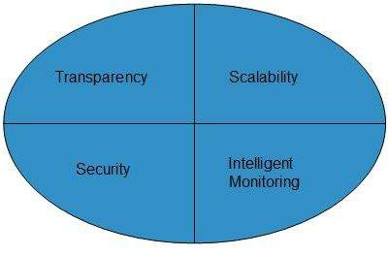

Transparency

Virtualization is the key to share resources in cloud environment. But it is not possible to satisfy the demand with single resource or server. Therefore, there must be transparency in resources, load balancing and application, so that we can scale them on demand.

Scalability

Scaling up an application delivery solution is not that easy as scaling up an application because it involves configuration overhead or even re-architecting the network. So, application delivery solution is need to be scalable which will require the virtual infrastructure such that resource can be provisioned and de-provisioned easily.

Intelligent Monitoring

To achieve transparency and scalability, application solution delivery will need to be capable of intelligent monitoring.

Security

The mega data center in the cloud should be securely architected. Also the control node, an entry point in mega data center, also needs to be secure.

4. Explain services and deployment models ?

Ans: **Three services in cloud computing**

**Software as a Service (SaaS).** The capability provided to the consumer is to use the provider’s applications running on a cloud infrastructure2. The applications are accessible from various client devices through either a thin client interface, such as a web browser (e.g., web-based email), or a program interface. The consumer does not manage or control the underlying cloud infrastructure including network, servers, operating systems, storage, or even individual application capabilities, with the possible exception of limited user-specific application configuration settings.

**Platform as a Service (PaaS)*.*** The capability provided to the consumer is to deploy onto the cloud infrastructure consumer-created or acquired applications created using programming languages, libraries, services, and tools supported by the provider.3 The consumer does not manage or control the underlying cloud infrastructure including network, servers, operating systems, or storage, but has control over the deployed applications and possibly configuration settings for the application-hosting environment.

**Infrastructure as a Service (IaaS).** The capability provided to the consumer is to provision processing, storage, networks, and other fundamental computing resources where the consumer is able to deploy and run arbitrary software, which can include operating systems and applications. The consumer does not manage or control the underlying cloud infrastructure but has control over operating systems, storage, and deployed applications; and possibly limited control of select networking components (e.g., host firewalls).

**Four deployment models:**

**Private cloud.** The cloud infrastructure is provisioned for exclusive use by a single organization comprising multiple consumers (e.g., business units). It may be owned, managed, and operated by the organization, a third party, or some combination of them, and it may exist on or off premises.

**Community cloud.** The cloud infrastructure is provisioned for exclusive use by a specific community of consumers from organizations that have shared concerns (e.g., mission, security requirements, policy, and compliance considerations). It may be owned, managed, and operated by one or more of the organizations in the community, a third party, or some combination of them, and it may exist on or off premises.

**Public cloud.** The cloud infrastructure is provisioned for open use by the general public. It may be owned, managed, and operated by a business, academic, or government organization, or some combination of them. It exists on the premises of the cloud provider.

**Hybrid cloud*.*** The cloud infrastructure is a composition of two or more distinct cloud infrastructures (private, community, or public) that remain unique entities, but are bound together by standardized or proprietary technology that enables data and application portability (e.g., cloud bursting for load balancing between clouds).

5. Explain public cloud including ? Advantages and disadvantages ?

Ans: The rise and adoption of public cloud services is one of the most important shifts in the history of enterprise computing. A public cloud is a type of [cloud computing](https://www.ibm.com/cloud/learn/cloud-computing) in which a third-party service provider makes computing resourceswhich can include anything from ready-to-use software applications, to individual [virtual machines (VMs)](https://www.ibm.com/cloud/learn/virtual-machines), to complete enterprise-grade infrastructures and development platforms available to users over the public Internet. These resources might be accessible for free, or access might be sold according to subscription-based or pay-per-usage pricing models.

The public cloud provider owns and administers the [data centers](https://www.ibm.com/cloud/learn/data-centers) where customers’ workloads run. Service providers assume responsibility for all hardware and infrastructure maintenance and provides high-bandwidth [network](https://www.ibm.com/cloud/learn/networking-a-complete-guide) connectivity to ensure rapid access to applications and data. The cloud provider also manages the underlying [virtualization](https://www.ibm.com/cloud/learn/virtualization-a-complete-guide) software. In its simplest form, the public cloud model is the computing version of the “utility” model we all use when consuming electricity or water in our homes.

**Advantages of public cloud computing :**

**1. Scalability**

Public cloud services comes with the auto scaling feature. Which means that all the virtual machines present inside the Public cloud system has the capability to get created, scaled, shutdown in an infinite speed. Therefore, ultimately the workload will be balanced according to the needs so that you can avoid downtime and crashes.

**2. Cost**

Since third party provides the Public cloud services, there is no need for an IT employee to look after and maintain the system. The cost of bandwidth, hardware and application are the sole responsibility of the provider. Hence, the initial investment here is almost zero. Moreover Public cloud services follows the model of pay-as-you-go which means that the payment is made monthly or annually according to the way the resources are being used.

**3. Maintenance**

All the users of the Public cloud infrastructure are free from the work of maintaining the cloud. The maintenance is solely taken care by the providers. Therefore, the users can focus on other sections of development and testing.

**4. Reliability**

Public cloud services offer greater reliability. This means there are very less chances of failure interrupting your service. The data center present on the network of servers can undergo frequent failure. Even if it does so, it will not be an issue since the work load will be distributed among the remaining data centers.

**5. Data Recovery**

A Disaster recovery plan is generally difficult and complex to deploy. That is the reason why most of the IT companies don't consider this implementation. However Public cloud has very little risk of loosing data here. This is because most of the multiple infrastructures available in the Public cloud services.

**Disadvantages of public cloud computing:**

**1. Security**

The security and privacy of data present inside a Public cloud service remains a concern for many businesses. The Public cloud services offered by many providers are secure to some extent. But the problem lies within the company and how they are going to use them. Therefore, companies must make use of cyber security practices. And also trust in the third party provider is also questioned since they can be from different country having their own set of security and privacy regulations.

**2. Flexibility**

Even though Public cloud services are very flexible in terms of scalability, there are issues for security and configurations. Some Public cloud providers does not grant freedom to install operating system or switch storage solutions. That is the reason why Public cloud services are not recommended for organizations with compliance regulations.

**3. No Control**

Using the Public cloud services means that you are sharing the same infrastructure with the other customers. The maintenance and the management has  been entirely taken care by the service provider. The users have no control over it.

**4. Customization**

The atmosphere of the Public cloud service can limit any customization process. Hence, customization of resources or services is almost made impossible in a Public cloud service. This can be disadvantageous especially to the companies with complex network architecture and application process.

**5. Customer Support**

Public cloud models lacks on the side of customer support. In fact it is a separate contract for the client. Customer support is an important point to remember since some providers does not deliver a quality service. Therefore, users need to discover solutions on their own.